
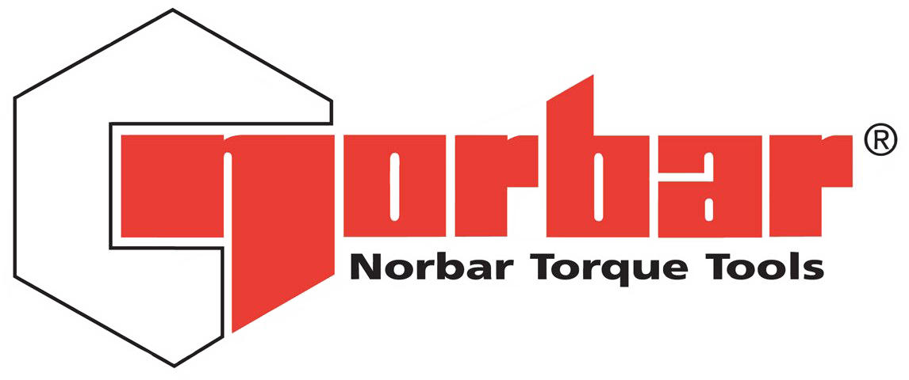
GOODS RETURN FORM RETURN ADDRESS
NORBAR TORQUE TOOLS LTD
Wildmere Road
Tel: +44 (0) 1295 753635 Banbury
Email: sales@norbar.com Oxfordshire
repairs@norbar.com OX16 3JU
United Kingdom

Please complete, print and include with the goods being returned.

Please send along with your Purchase Order if applicable.

Company Name
Contact Name
Address
Phone Number | Email Address:
Customer Order Number  (if applicable) | Norbar Order Number  (if applicable)
Norbar Contact Name | Date of Return:
Description of Goods | Model Number | Serial Number | Reason code* | Notes / Fault Details (if applicable)
*Reason Codes - List of Reason for Return Codes:
W – Warranty R – Repair C – UKAS Accredited Calibration D = Declaration of Conformance
S – Service Replacement G – Goods for Credit O – Other (Please Specify in Notes Section)

